**Appendix:**

Tope 10 words of 5 topics of lyrics in 2010s with $λ$ =0.3

|  |  |  |  |  |  |  |  |  |  |  |
| --- | --- | --- | --- | --- | --- | --- | --- | --- | --- | --- |
|  | Word1 | Word2 | Word3 | Word4 | Word5 | Word6 | Word7 | Word8 | Word9 | Word10 |
| Topic1 | know | got | talk | german | alejandro | cause | impossible | try | hold | heart |
| Topic2 | taste | let | love | time | like | baby | whats | ryan | came | lewis |
| Topic3 | rollie | byebye | yellow | know | titanium | deuces | dab | back | feel | see |
| Topic4 | low | way | treasure | work | pickin | romance | trouble | thank | love | grateful |
| Topic5 | burn | tamed | trumpets | girlfriend | saxobeat | daddys | malibu | Therapy | fire | gave |

Tope 10 words of 5 topics of lyrics in 2000s with $λ$ =0.3

|  |  |  |  |  |  |  |  |  |  |  |
| --- | --- | --- | --- | --- | --- | --- | --- | --- | --- | --- |
|  | Word1 | Word2 | Word3 | Word4 | Word5 | Word6 | Word7 | Word8 | Word9 | Word10 |
| Topic1 | love | baby | way | soujia | crank | need | boy | watch | lockdown | wish |
| Topic2 | go | like | fight | know | got | make | raining | life | clouds | miya |
| Topic3 | womanizer | mercy | never | got | try | begging | shut | believe | send | know |
| Topic4 | suga | party | like | bulletproof | lifted | celebrate | intricate | star | shifted | get |
| Topic5 | bedum | disturbia | untouched | think | call | laffy | shakira | taffy | liar | home |

Tope 10 words of 5 topics of lyrics in 1990s with $λ$ =0.3

|  |  |  |  |  |  |  |  |  |  |  |
| --- | --- | --- | --- | --- | --- | --- | --- | --- | --- | --- |
|  | Word1 | Word2 | Word3 | Word4 | Word5 | Word6 | Word7 | Word8 | Word9 | Word10 |
| Topic1 | love | baby | hello | like | give | life | beside | babe | lala | chains |
| Topic2 | yeah | shoo | whoaoh | hey | shooby | doop | mack | long | ever | baby |
| Topic3 | quit | boomcha | heart | know | playing | discotheque | barbie | American | love | games |
| Topic4 | dobeda | oh | ah | step | thunderstruck | mercy | dont | crolina | prowl | hallelujah |
| Topic5 | firestarter | jones | whatta | imagination | doctor | wont | whoomp | crossroads | mighty | promise |

Tope 10 words of 5 topics of lyrics in 1980s with $λ$ =0.3

|  |  |  |  |  |  |  |  |  |  |  |
| --- | --- | --- | --- | --- | --- | --- | --- | --- | --- | --- |
|  | Word1 | Word2 | Word3 | Word4 | Word5 | Word6 | Word7 | Word8 | Word9 | Word10 |
| Topic1 | love | baby | got | oh | shack | heart | dude | dance | ive | time |
| Topic2 | mony | hey | mickey | going | yeah | dont | underground | stomp | cant | beat |
| Topic3 | chika | bow | chick | oh | give | oo | girl | vie | dont | square |
| Topic4 | chaka | weak | love | khan | mercy | boardwalk | rock | baba | seeds | sowing |
| Topic5 | poison | miss | boyohi | wonderful | much | self | prudence | hot | cried | fatal |

Tope 10 words of 5 topics of lyrics in 1970s with $λ$ =0.3

|  |  |  |  |  |  |  |  |  |  |  |
| --- | --- | --- | --- | --- | --- | --- | --- | --- | --- | --- |
|  | Word1 | Word2 | Word3 | Word4 | Word5 | Word6 | Word7 | Word8 | Word9 | Word10 |
| Topic1 | youre | soley | ooh | lonely | dont | oh | breaking | bon | gonna | soleley |
| Topic2 | love | deeya | badeeya | oh | toot | beep | lookin | boat | sweet | temtation |
| Topic3 | chance | atake | Saturday | crash | 48 | woman | night | real | evil | sharing |
| Topic4 | hit | Bump | fever | telegram | shes | boogie | volezvous | sally | mercy | whoa |
| Topic5 | baby | bye | burn | goodnight | hot | rocky | say | colorado | sealed | worry |

Tope 10 words of 5 topics of lyrics in 1960s with $λ$ =0.3

|  |  |  |  |  |  |  |  |  |  |  |
| --- | --- | --- | --- | --- | --- | --- | --- | --- | --- | --- |
|  | Word1 | Word2 | Word3 | Word4 | Word5 | Word6 | Word7 | Word8 | Word9 | Word10 |
| Topic1 | baby | woman | enough | walk | pretty | away | mountain | shot | abilence | love |
| Topic2 | lifting | gurdy | higher | hurdy | little | chain | deeper | rudy | rock | twist |
| Topic3 | USA | surfin | fire | outside | bang | georgy | light | try | satisfy | set |
| Topic4 | lovely | stand | day | maggies | boardwalk | dancn | twistin | round | prayer | darlin |
| Topic5 | lie | jimmy | postman | mack | sugar | monday | minute | oscillations | maybellence | icy |

Tope 10 words of 5 topics of lyrics in 1950s with $λ$ =0.3

|  |  |  |  |  |  |  |  |  |  |  |
| --- | --- | --- | --- | --- | --- | --- | --- | --- | --- | --- |
|  | Word1 | Word2 | Word3 | Word4 | Word5 | Word6 | Word7 | Word8 | Word9 | Word10 |
| Topic1 | hanky | panky | hills | yakety | jailhouse | dakota | indian | stagger | right | rock |
| Topic2 | ron | peggy | never | wan | work | mess | flo | cruel | return | home |
| Topic3 | bye | fever | kick | ways | lucille | hello | dream | sigh | hit | lazy |
| Topic4 | blue | shoes | suede | susie | wake | anything | ready | lay | wheel | teddy |
| Topic5 | postman | shame | cupid | thunb | fall | molly | blame | frutti | rooty | stupid |

2010s

图表

2000s

1990s

1980s

图形用户界面

1970s

1960s

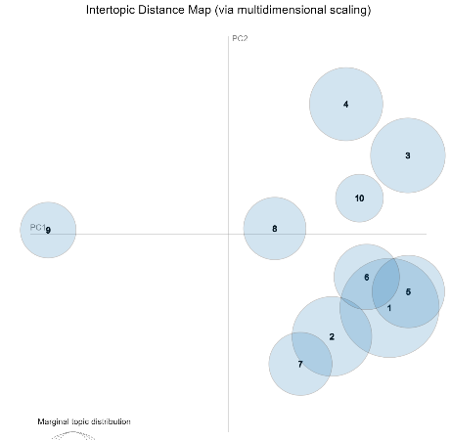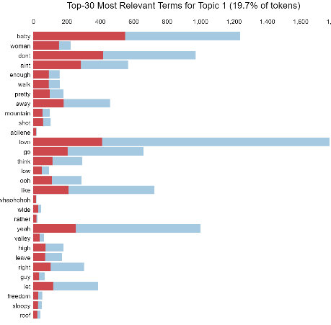

1950s

